ARCHITECTURE

TrustQuery AI — Architecture
A four-layer model — ingestion & parsing, knowledge & RAG, multi-agent generation, and validation & evaluation — with four concerns cutting across every layer.
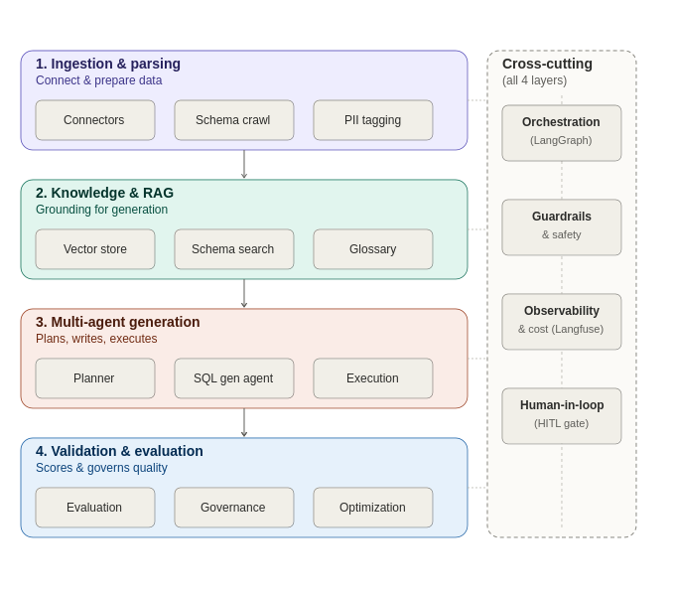

The four layers

1. Ingestion & parsing
Connects to source systems, crawls schema and table/column metadata, and applies sensitivity tags (PII, confidential, public) that every downstream layer relies on. Runs on a recurring cadence (e.g., nightly) so the system stays current as schemas evolve, rather than being a one-time setup step.
- Data connectors — pull schema and sample data from source systems (Turso for this prototype)
- Schema crawler — keeps table/column metadata current
- Sensitivity tagging — flags PII and confidential columns at the source, before anything is retrieved or generated against them

2. Knowledge & RAG
Holds the grounding material the generation layer retrieves from: embedded schema descriptions, few-shot query exemplars, and business glossary terms. This is what keeps SQL generation accurate without needing the full schema stuffed into every prompt.
- Vector store — ChromaDB, embedding schema and exemplar text for retrieval
- Schema search — retrieves only the relevant tables/columns for a given question
- Business glossary — maps business terminology to underlying schema (e.g., "churned customer" to the relevant status columns)

3. Multi-agent generation
The live, conversational path: a Planner agent routes the question, a SQL Generation agent writes the query grounded in what Layer 2 retrieved, and an Execution agent runs it with a bounded self-healing retry loop on failure. The HITL gate (a cross-cutting concern, detailed below) sits structurally between generation and execution for queries that need a human check first.
- Planner — interprets the question and decides the routing path
- SQL generation agent — writes the query from retrieved schema and exemplars
- Execution agent — runs the query and self-corrects on error before returning a result

4. Validation & evaluation
Runs continuously alongside live traffic rather than only at release time: scoring accuracy, enforcing data masking independent of the HITL gate, and deciding when prompt tuning or fine-tuning is warranted. This is what keeps quality from silently drifting after launch.
- Evaluation — DeepEval scores query correctness against a golden test set, natively traced through LangGraph
- Governance — independently masks sensitive columns in every result set, whether or not a query was HITL-approved
- Optimization — decides between adding few-shot exemplars, prompt tuning via DSPy, or fine-tuning via PEFT/LoRA

Cross-cutting concerns
These four capabilities aren't separate agents confined to one layer — they're threaded through all four, and that's deliberate: bolting governance or observability on after the fact tends to leave gaps at the layer boundaries.

Orchestration (LangGraph)
A single graph-based orchestration framework coordinates state and hand-offs from ingestion through validation. Its explicit state model and interrupt/checkpoint support are what make the asynchronous HITL pause-and-resume possible without bespoke plumbing.

Guardrails & safety
Sensitivity tagging at ingestion, schema-scoped retrieval at the RAG layer, query-safety checks before execution, and automatic masking at validation — safety isn't one checkpoint, it's reinforced at each layer so a gap in one doesn't become a leak.

Observability & cost (Langfuse)
Self-hosted Langfuse traces every layer's activity — ingestion runs, retrieval latency, generation and execution spans, and validation scores — giving one unified view rather than per-layer logging silos. DeepEval's scores are pushed into Langfuse and attached to the originating trace rather than living in a separate dashboard.

Human-in-the-loop
The HITL gate in Layer 3 is the most visible instance, but human review touches every layer: business SMEs curate the golden dataset and glossary terms at ingestion, reviewers approve flagged queries at generation, and a human signs off before the Optimization agent's fine-tuned models get promoted to production at validation.

